TEMPLATE OF FULL TEXT
(EXPERIENCES)

Title (Times New Roman, size 14, centered)
Surname, Name of Author 1
Surname, Name of Author 2
Surname, Name of Author 3

Department
University (Country)
(Times New Roman, size 12, aligned right wing, single line spacing. When authors are from different universities, they will appear separated)

Example:

Campbell, Robert
Department of Education
University of California (United States)

López López, María
Valverde Rioja, Francisco
Departamento de Pedagogía y Didáctica
Universidad de Santiago de Compostela (Spain)

Abstract
(Times New Roman, size 12, justified text, single line spacing). Maximum 150 words.
Keywords (Times New Roman, size 12, justified text, separated by ;). 3-5 keywords.

Título (Times New Roman, tamaño 12 pt., alineación centrada)
Resumen
(Times New Roman, tamaño 12 pt., alineación justificada, interlineado sencillo). Máximo 150 palabras.
Palabras clave (Times New Roman, tamaño 12 pt., alineación justificada, separadas por “;”). 3-5 palabras clave.

Presentation modality: Oral communication / Poster communication.

Introduction
(Times New Roman, size 12, justified text, single line spacing). Please check, before continuing, that has followed the instructions of the Organizing Committee on the format of communication (font size, alignment ...).
You should also take into account that the maximum size of the text is 4,000 words, including abstract and references.
Indent the first line (1.25 cm) in all paragraphs. The space between paragraphs is 6 pt., both before and after, throughout the text. The work presented must not be paginated nor contain section breaks, and headers.
In terms of content, this section should refer to the nature and purpose of work.

Contextualization
(Times New Roman, size 12, justified text, single line spacing). This section includes a description of the scope in which the experience has been developed, students, participation, entities, etc. It will be divided into sub-items (1.1., 1.2., ...) deemed appropriate.

Experience description
(Times New Roman, size 12, justified text, single line spacing). This section describes the starting needs and the service experience that responses to these social needs.
Tables, figures and graphics will be inserted in the text (not at the end) and must be consecutively numbered (1, 2, 3 ...).
Table 1. Table example (Times New Roman, 12, centered)
Column header | Column A | Column B
First line | 1 | 1
Second line | 5 | 2
Third line | 6 | 3
Source. Own elaboration (Times New Roman, 10, centered)
Figure 1. Figure example (Times New Roman, 12 pt., centered)
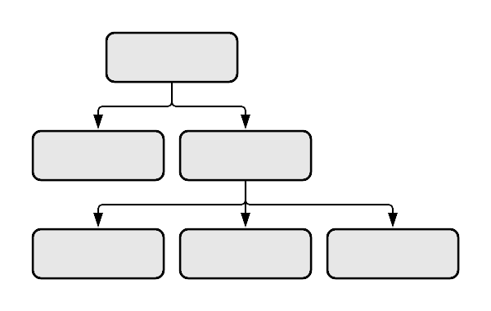
Source. Own elaboration (Times New Roman, 10, centered)

Conclusions
All communications must have a section in which the most important conclusions of the experience that has been carried out are collected.

References
The references shall constitute the final section of the Communication and must be prepared in APA 6th Edition. The authors must ensure that every reference in the text will appear in the literature, and vice versa.
Regarding the format, it will have a font size Times New Roman, 12, Justified, single line spacing and hanging indent (1.25 cm).
Some examples:
Book
Santos Rego, M. A., Lorenzo Moledo, M., & Vázquez Rodríguez, A. (2018). Educación no formal y empleabilidad de la juventud. Madrid: Síntesis.
Book chapter
Suárez Orozco, M. & Baolian, D. (2006). Globalización: cultura y educación en el milenio. In I. A. Gómez Cavazos (Coord.), Globalización y justicia internacional (pp. 129-177). México D.F.: Fondo de Cultura Económica.
Journal article
Buxarrais, M. R. (2016). Redes Sociales y Educación. Education in the Knowledge Society, 17(2), 15-20.

Footnotes
Footnotes should be avoided whenever possible. When necessary, they should be entered in the text with consecutive numbers in superscript. Notes should be typed single-spaced, with a font size (8) smaller, in the same page where are included and separated from the main text by a line inserted at the bottom of the column.

